043母线系统图
Data from Electrical Power & Energy System (Vol. 12 No.3 July 1990) pp.194
Diagram by Lei SHI 2000.2.28

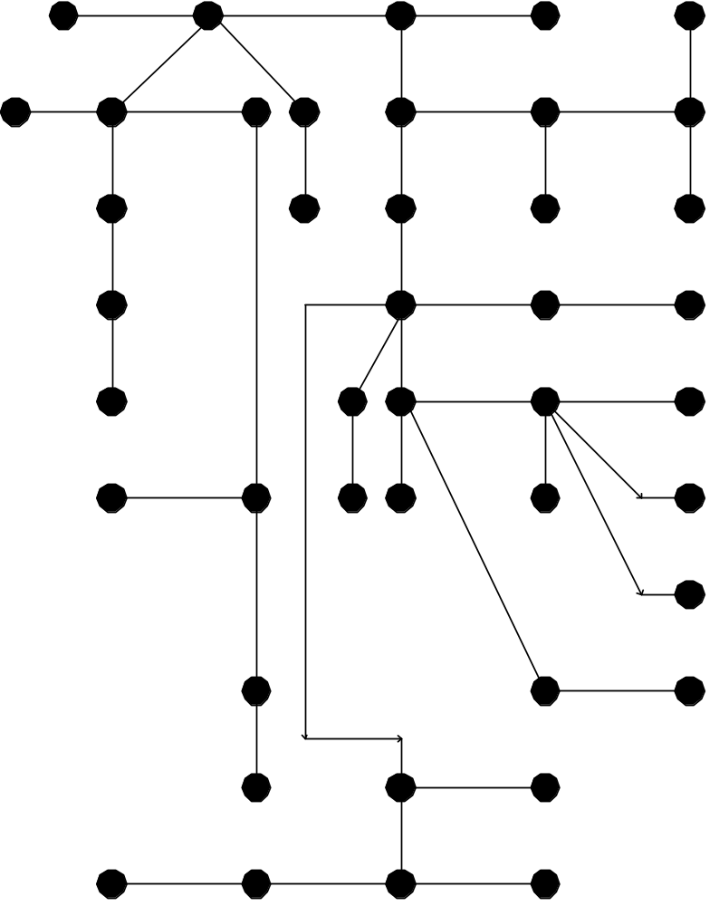 Slack node
1
2
5
7
17
20
15
28
6
12
8
9
1
10
19
22
26
23
16
11
29
37
31
21
30
38
33
41
39
24
32
35
36
34
43
40
42
14
25
27
3
4
13
18

